**Board Book Tab - Paccar**

***Current State***

During an economic slowdown which typically increases the demand for aftermarket parts, Paccar established an improvement process in managing the supply chain and improve the distribution center fill rate. From the information and data given, we computed Paccar’s current national fill rate is around 97%, and the regional fill rate is around 93%. Digging into the data, we find the there are 8,688 items with less than 50% of national fill rate. Another finding we will discussed later is that and the company spent 82 million per month to maintain and improve the safety stock. We plan to find new solutions to maintain and improve fill rates.

***External & Internal Factor***

1. Seasonality. We believe that seasonality will affect our fill rate performance. For example, during the holiday season, the delivery time from suppliers may delay and eventually lower our fill rate.
2. Inventory Planner Velocity. Slow velocity for inventory planner will have a negative impact on fill rates.
3. Manufacturing capacity. Manufacturing capacity may affect fill rate especially under the situation where the the demand may sudden increase.
4. Safety Stock Model. The safety stock model could be a critical internal influence for the performing since it could affect both total cost and the fill rate.

***Data interpretation and visualizations***

1. CGS has the lowest regional fill rate around 63%. PTY has the lowest national fill rate around 64% and a relatively low regional fill rate for 73%. CGS only has data from June to July 2017, we believe that it became inactive after July 2017. Hence, we decided not to take CGS into consideration any more.
2. It is no surprising that there are radical increases in average shipping days, past due and backorder quantities in December due to the holiday season. After December 2017, backorder quantity and average shipping days drop steadily.
3. 95.37% items with less than 50% national fill rate have the slowest velocity for inventory planner while in general on 70.15% fall into the slowest category.

***Data assumptions***

1. We assume that ordering from the regional warehouse will give us the shortest lead time for each item. Longer lead time of each item comes from the national orders. Therefore, for the lead time of each item, we group it into two category -- regional lead time and national lead time.
2. If an item has a zero national fill rate in one PDC, but it can be distributed from other PDC in the same month, we assume that this item line can actually be fulfilled by other PDC.
3. The original dataset shows that CGS only has data in June 2017 and July 2017, we assume that it became inactive after that time.
4. If the national fill rate is lower than 50%, we treat the item as low national fill rate item.
5. We assume that the average cost disclosed in the parts info table include storage cost.
6. We assume that the longer the lead time of the item, the longer overdue days will be.
7. We assume the planning desk is different departments.
8. Given data set does not provide overdue date directly, therefore we chose a proxy to estimate: LTM.

***Analysis (Model Methodology)***

We first want to analyze the PDC Stock to see the impact on national fill rate. We decided not to take CGS and PTY into consideration since the there is not enough data or transactions. After grouping the 9 warehouses and removing the item with zero national fill rate , we improve the national fill rate by 1%.

Then we would like to use the seasonality analysis to detect some patterns. First, we consolidated data regarding to these low fill rate items together, and found out that the trend of Past Due Quantity, BackOrder Quantity and days to ship is very consistent for low fill rate items. Besides, we noticed that there is a one to two month gap between the BackOrder Quantity trend and the Past Due Quantity trend. Another noticeable pattern is that for all three lines December is the peak month.

After grouping each transaction by velocity of inventory planner and item code, we found that 70.15% of items are ordered by slowest inventory planner, while about 30% of items are ordered by faster inventory planners, and 95% items are ordered by slowest inventory planner.

Based on the above analysis, we can tell that slow velocity for inventory planner will have a negative impact on fill rates, if we can improve the velocity of inventory planner for ordering parts, fill rates are expected to be improved. In addition, we noticed that K9 constitutes the largest part among all planning desks.

For safety stock analysis, we applied a nonlinear function to the LTM to get a preliminary estimation of overdue date, adjusted the estimation with its t-stat as a parameter, used safety stock formula and multiplied the estimated by z score to capture our 99.99% targeted National Fill rate, and incorporated current safety stock and current national fill rate of items to our estimation. As a result, we increased the safety stock days of the 1,761 items, which have low national fill rate. Besides, we reduced safety stock days of the 3,230 items with overestimated safety stock. We adopted periodical review model and compared the monthly cost of maintaining current safety stock time and our recommended safety stock days, saving $16 million out of the tial $82 million cost.

***Final Recommendations***

1. We recommend eliminating PDC lines with zero national fill rate if it can be distributed by other PDC in the same month. If with more information available, our next step is to associate cost in the analysis.
2. We should increase safety stock during the holiday season to avoid the potential shipping delay from supplier.
3. Improve the inventory planner velocity to increase the national fill rate.
4. Based on these patterns, we recommend for the holiday season, the month of December, increase the safety stock units before the month to make sure stock can cover the gap period caused by larger past due quantities and longer shipping days to improve the fill rate for the low fill rate items.
5. We recommend in the long run, improve the inventory planner ordering velocity. It can be achieved by sustaining ability to improve and grow, such as having regular training and internal employee incentive program.
6. Therefore, in the short term, we recommend prioritizing improving velocity in planning desk K.
7. In the manufacturing, we recommend boosting manufacturing capacity for high-demand products.
8. We would like to improve the velocity of inventory planner for ordering parts in order to improve the fill rates.

***Key Technology Disruptors***

1. Weather Conditions: During winter season, the severe weather conditions will affect the freight shipment, resulting in longer shipping days.
2. Electrification and driver automation in trucking: Due to the technology growing, electrification and driver automation in trucking may potentially challenge the traditional trucking industry.
3. Driver Shortage: During holiday season, there might be a shortage in drivers.
4. Customer Demand Cycle: During the holiday season, there will be increase in the customer demand.

Appendix 1

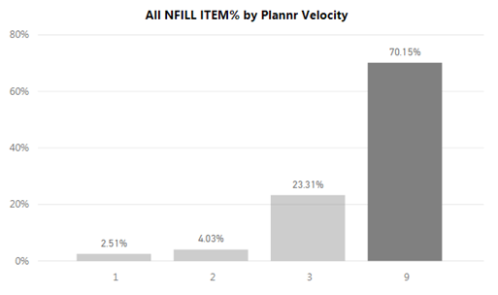

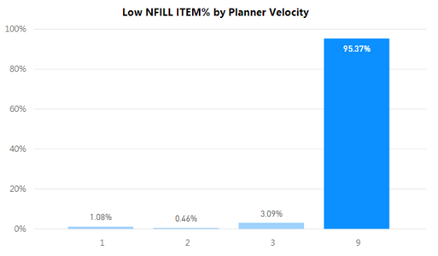



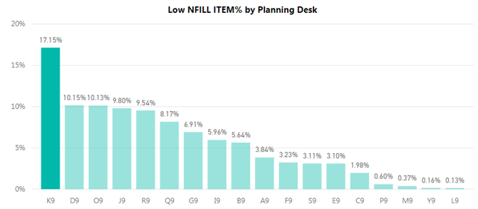

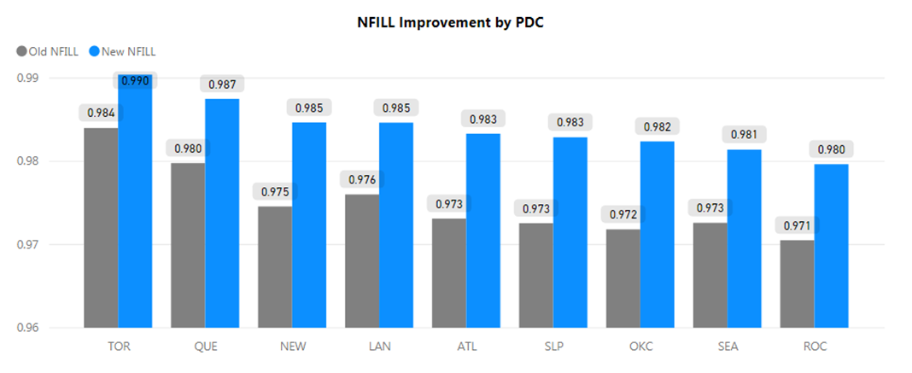

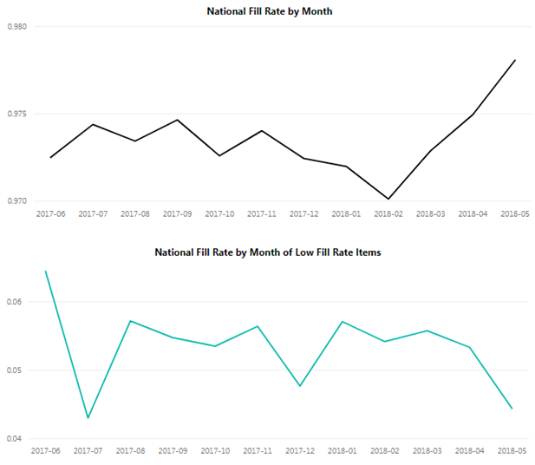

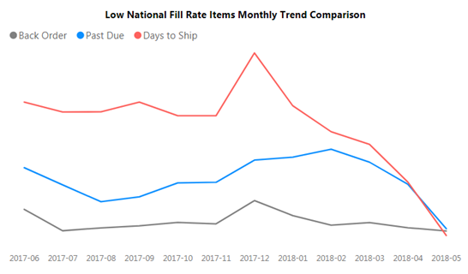

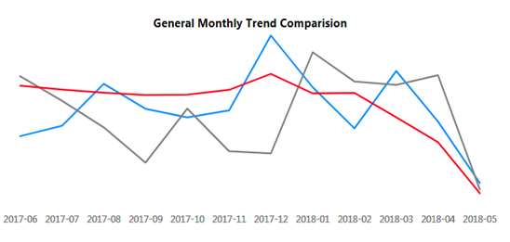

Appendix 2

**SQL Code:**

/*LTM.sql*/

USE yangq1_winter2017;

SELECT COUNT(*) FROM [SU - 12M Fill & Inventory Data Part Info]

SELECT COUNT(DISTINCT(ITEM)) FROM [SU - 12M Fill & Inventory Data Part Info]

IF OBJECT_ID('RLTM') IS NOT NULL

DROP TABLE RLTM

SELECT * INTO RLTM FROM(

SELECT ITEM, SUPPLIER, MIN(PURCHASE_LTM) AS RLTM FROM [SU - 12M Fill & Inventory Data Part Info]

GROUP BY ITEM, SUPPLIER)a

SELECT TOP 10 * FROM [SU - 12M Fill & Inventory Data Part Info]

--select top 10 * from fullRLTM

select count(*) from [SU - 12M Fill & Inventory Data Part Info]

GROUP BY ITEM, SUPPLIER -- 30504

--add row# by item and supplier, id as primary key

--LEFT JOIN W/original table

IF OBJECT_ID('FULLRLTM') IS NOT NULL

DROP TABLE FULLRLTM;

SELECT * INTO FULLRLTM FROM(

SELECT ROW_NUMBER() OVER(PARTITION BY t.ITEM, t.SUPPLIER ORDER BY PURCHASE_LTM ASC) AS Row#,

t.*, r.RLTM FROM [SU - 12M Fill & Inventory Data Part Info] as t

LEFT JOIN RLTM as r ON t.ITEM = r.ITEM AND t.SUPPLIER = r.SUPPLIER)a

ALTER TABLE FULLRLTM ADD id INT IDENTITY(1,1)

GO

select * from FULLRLTM -- 92315

--make a copy of FULLRLTM to remove the row in FULLRLTM with smallest LTM (row# =1)

IF OBJECT_ID('FULLRLTM_BAK') IS NOT NULL

DROP TABLE FULLRLTM_BAK;

SELECT * INTO FULLRLTM_BAK FROM(

SELECT * FROM FULLRLTM)a -- 92315

--SELECT * FROM FULLRLTM_BAK

--ALL ITEM, SUPPLIER COMBINATION WITH ONLY ONE COUNT

IF OBJECT_ID('LTM1') IS NOT NULL

DROP TABLE LTM1;

SELECT * INTO LTM1 FROM(

SELECT ITEM, SUPPLIER, COUNT(*)as ItemSupplierCount from FULLRLTM_BAK

GROUP BY ITEM, SUPPLIER)a -- 30504

--select * from LTM1 -- item, supplier, itemsuppliercount

select count(*) from LTM1

where ItemSupplierCount = 1 -- 13995

IF OBJECT_ID('LTM1_semiFinal') IS NOT NULL

DROP TABLE LTM1_semiFinal;

SELECT * INTO LTM1_semiFinal FROM(

SELECT * FROM LTM1

WHERE ItemSupplierCount = 1)a -- 13995

--select * from LTM1_Final -- 13995

-- add id to LTM1_semiFinal

IF OBJECT_ID('LTM1_Final') IS NOT NULL

DROP TABLE LTM1_Final;

SELECT * INTO LTM1_Final FROM(

select l.*, f.id from LTM1_semiFinal as l

left join FULLRLTM as f

on l.ITEM = f.ITEM and l.SUPPLIER = f.SUPPLIER)a

select * from LTM1_Final -- 13995

SELECT * FROM FULLRLTM_BAK -- 92315

select sum(ItemSupplierCount) from LTM1

where ItemSupplierCount > 1 -- count: 16509, sum: 78320

--JOIN FULLRLTM_BAK with LTM1 (only itemsupplier > 1)

IF OBJECT_ID('LTMgt1') IS NOT NULL

DROP TABLE LTMgt1

SELECT * INTO LTMgt1 FROM(

SELECT f.*, l.ItemSupplierCount FROM FULLRLTM_BAK AS f

JOIN LTM1 AS l ON f.ITEM = l.ITEM AND f.SUPPLIER = l.SUPPLIER

WHERE l.ItemSupplierCount > 1)a

SELECT * FROM LTMgt1 -- 78320

--remove row# = 1 from LTMgt1

DELETE FROM LTMgt1

WHERE ROW# = 1 -- 16509

SELECT * FROM LTMgt1 -- 61811

--get avg LTM as NLTM in LTMgt1

-- if median: WHERE Rank = (SELECT (COUNT(*)+1) DIV 2 FROM Total_Sales)

-- https://www.1keydata.com/sql/sql-median.html

IF OBJECT_ID('LTMgt1_Final') IS NOT NULL

DROP TABLE LTMgt1_Final

SELECT * INTO LTMgt1_Final FROM(

SELECT ITEM, SUPPLIER, AVG(CONVERT(INT, PURCHASE_LTM)) AS NLTM FROM LTMgt1

GROUP BY ITEM, SUPPLIER)a

select * from LTMgt1_Final -- 16509

-- add NLTM from LTMgt1_Final(16509) to FULLRLTM (92315)

IF OBJECT_ID('FULLLTMgt1') IS NOT NULL

DROP TABLE FULLLTMgt1

SELECT * INTO FULLLTMgt1 FROM(

SELECT f.*, l.NLTM FROM LTMgt1_Final as l

RIGHT JOIN FULLRLTM f ON l.ITEM = f.ITEM AND l.SUPPLIER = f.SUPPLIER)a

select top 10 * from LTM1_Final

select top 10 * from FULLLTMgt1

-- set NLTM as RLTM in FULLLTMgt1 (92315) when id in LTM1_Final(13995)

update FULLLTMgt1

set NLTM = RLTM

WHERE ID in (select id from LTM1_Final)

SELECT * FROM FULLLTMgt1 -- 92315

-- final table FULLLTM

IF OBJECT_ID('FULLLTM') IS NOT NULL

DROP TABLE FULLLTM;

SELECT * INTO FULLLTM FROM(

SELECT * FROM FULLLTMgt1)a

select * from FULLLTM

WHERE RLTM = 0

select distinct(RLTM) FROM FULLLTM

ORDER BY RLTM

--where id = 107

-- convert LTM to past due date (PDD) and save to FULLPDD table

IF OBJECT_ID('FULLPDD_semiFinal') IS NOT NULL

DROP TABLE FULLPDD_semiFinal

SELECT * INTO FULLPDD_semiFinal FROM(

select *,

CASE WHEN RLTM = 0 THEN 0

WHEN CONVERT(INT, RLTM) < 22 THEN log(CONVERT(float, RLTM),1.6)

ELSE (0.3 * CONVERT(FLOAT, RLTM))

END AS RPDD,

CASE WHEN NLTM = 0 THEN 0

WHEN CONVERT(INT, NLTM) < 22 THEN log(CONVERT(float, NLTM),1.6)

ELSE (0.3 * CONVERT(FLOAT, NLTM))

END AS NPDD

from FULLLTM)a

--select * from FULLPDD_semiFinal

/*GROUP FULLPDD_semiFinal BY ITEM AND SUPPLIER*/

/*FILTER COLUMNS EXCEPT AVG OF AVG_COST, PURCHASE_LTM, MIN ID, NTLM, NPDD*/

IF OBJECT_ID('FULLPDD') IS NOT NULL

DROP TABLE FULLPDD

SELECT * INTO FULLPDD FROM(

SELECT MIN(ID) AS ID, ITEM, SUPPLIER,

--AVG(convert(INT, PURCHASE_LTM)) AS PURCHASE_LTM,

AVG(CONVERT(FLOAT, AVG_COST)) AS AVG_COST,

AVG(NLTM) AS NLTM,

AVG(NPDD) AS NPDD

FROM FULLPDD_semiFinal

GROUP BY ITEM, SUPPLIER)a -- 30504

select * from FULLPDD

/*

select * from FULLLTMgt1

where NLTM is null

AND ID NOT IN (SELECT ID FROM LTMgt1)

*/

--SELECT * FROM FULLRLTM

/*

--mean of remaining LTM as NLTM

IF OBJECT_ID('FULLLTM') IS NOT NULL

DROP TABLE FULLLTM;

SELECT * INTO FULLLTM FROM(

SELECT ITEM, SUPPLIER, AVG(CONVERT(int, RLTM)) AS RLTM, AVG(CONVERT(INT, PURCHASE_LTM)) AS NLTM FROM FULLRLTM

GROUP BY ITEM, SUPPLIER)a

select * from [SU - 12M Fill & Inventory Data Part Info]

where item = 'T96-CLL673470'

select ITEM, SUPPLIER from FULLLTM

WHERE ITEM NOT IN (SELECT ITEM FROM [SU - 12M Fill & Inventory Data Part Info]) AND SUPPLIER NOT IN (SELECT SUPPLIER FROM [SU - 12M Fill & Inventory Data Part Info])

*/

/**/

/*OTS.sql*/

USE yangq1_winter2017;

/* OTS % BY SUPPLIER */

IF OBJECT_ID('tableA') IS NOT NULL

DROP TABLE tableA

select COUNT(DISTINCT(VEND)) from [dbo].[SU - 12M Fill & Inventory Data OTS]

select * into tableA from (

SELECT ROW_NUMBER() OVER(PARTITION BY Vend order BY [Month]) AS Row#, * FROM [dbo].[SU - 12M Fill & Inventory Data OTS])a

IF OBJECT_ID('VendAvgOTS') IS NOT NULL

DROP TABLE VendAvgOTS

select * into VendAvgOTS FROM(

select Vend, AVG(OTS) as avg_OTS

FROM [SU - 12M Fill & Inventory Data OTS]

GROUP BY Vend)a

select avg(avg_ots) as Mean_OTS, STDEV(avg_ots) as sd from VendAvgOTS

--Mean_OTS = 0.700213864538239, sd = 0.272605955365203

-- calculate T stat of avgOTS and save to VendAvgOTSTStat

DECLARE @Mean_OTS float;

DECLARE @sd float;

SET @Mean_OTS = (select avg(avg_ots) from VendAvgOTS);

SET @sd = (select STDEV(avg_ots) from VendAvgOTS);

IF OBJECT_ID('VendAvgOTSTStat') IS NOT NULL

DROP TABLE VendAvgOTSTStat

SELECT * INTO VendAvgOTSTStat FROM(

SELECT *, ([avg_OTS] - @Mean_OTS)/@sd as [t-stat] FROM VendAvgOTS)a

select * from VendAvgOTSTStat

/* Join FULLPDD with VendAvgOTSTStat on supplier*/

--select count(*) from FULLPDD

IF OBJECT_ID('FULLPDDOTS') IS NOT NULL

DROP TABLE FULLPDDOTS

SELECT * INTO FULLPDDOTS FROM(

SELECT p.*, o.avg_OTS, o.[t-stat] FROM FULLPDD AS p

LEFT JOIN VendAvgOTSTStat as o

on p.SUPPLIER = o.vend)a -- 30504

/*Adjust NPDD based on OTS t-stat*/

/*PDD/t-stat when t stat > 1*/

--SELECT * FROM FULLPDDOTS

--WHERE [t-stat] < -1

UPDATE FULLPDDOTS

SET NPDD = NPDD/[t-stat]

WHERE [t-stat] > 1

/*PDD*t-stat when t stat < -1*/

UPDATE FULLPDDOTS

SET NPDD = abs(NPDD*[t-stat])

WHERE [t-stat] < -1

select * from FULLPDDOTS -- 30504

/*Demand.sql*/

USE yangq1_winter2017;

/* Demand */

select top 10 * from [dbo].[ SU - 12M Fill _ Inventory Data Demand]

select count(*) from [dbo].[ SU - 12M Fill _ Inventory Data Demand]-- 822847

SELECT COUNT(DISTINCT(ITEM)) FROM [dbo].[ SU - 12M Fill _ Inventory Data Demand] -- 26088

/*count distinct Month per ITEM*/

IF OBJECT_ID('DemandTotalCount') IS NOT NULL

DROP TABLE DemandTotalCount;

SELECT * INTO DemandTotalCount FROM(

SELECT ITEM, COUNT(DISTINCT[Month]) as MonthCount, SUM(CONVERT(INT, Qty_Ord)) as TotalQty

FROM [dbo].[ SU - 12M Fill _ Inventory Data Demand]

GROUP BY ITEM)a -- 26088

--select * from DemandTotalCount

IF OBJECT_ID('DailyDemand') IS NOT NULL

DROP TABLE DailyDemand;

SELECT * INTO DailyDemand FROM(

select *, convert(float, convert(float, totalQty) / MonthCount) as MonthlyQty,

convert(float, totalQty) / (MonthCount * 30) as DailyQty FROM DemandTotalCount)a --26088

select * from DailyDemand -- 26088

/*PDDDailyDemand.sql*/

USE yangq1_winter2017;

SELECT * FROM FULLPDDOTS -- 30504

SELECT COUNT(DISTINCT(ITEM)) FROM FULLPDDOTS -- 26145

SELECT * FROM DAILYDEMAND -- 26088

SELECT COUNT(DISTINCT(ITEM)) FROM DAILYDEMAND -- 26088

IF OBJECT_ID('FULLPDDOTSDAILYDEMAND') IS NOT NULL

DROP TABLE FULLPDDOTSDAILYDEMAND

SELECT * INTO FULLPDDOTSDAILYDEMAND FROM(

SELECT f.*, d.DailyQty FROM FULLPDDOTS AS f

LEFT JOIN DAILYDEMAND as d

ON f.ITEM = d.ITEM)a --30504

SELECT TOP 10 * FROM FULLPDDOTSDAILYDEMAND

/*Adjust NPDD based on DAILY DEMAND*/

UPDATE FULLPDDOTSDAILYDEMAND

SET NPDD = (1/DAILYQty)

WHERE NPDD * DAILYQty < 1

select * from FULLPDDOTSDAILYDEMAND -- 30504

/*NFILLRATE.sql*/

USE yangq1_winter2017;

select * from [dbo].[ SU - 12M Fill _ Inventory Data Demand] -- 822847

SELECT COUNT(DISTINCT(ITEM)) FROM [dbo].[ SU - 12M Fill _ Inventory Data Demand] -- 26088

IF OBJECT_ID('NFILLRATE') IS NOT NULL

DROP TABLE NFILLRATE

SELECT * INTO NFILLRATE FROM(

select item, sum(CONVERT(INT, nline)) as sumNLINE, sum(CONVERT(INT, NHIT)) AS sumNHIT FROM [dbo].[ SU - 12M Fill _ Inventory Data Demand]

GROUP BY ITEM)a

IF OBJECT_ID('NFILLRATE_Final') IS NOT NULL

DROP TABLE NFILLRATE_Final

SELECT * INTO NFILLRATE_Final FROM(

SELECT *, (sumNLINE-sumNHIT)/CONVERT(FLOAT, sumNLINE) AS NFILLRATE FROM NFILLRATE)a --26088

--select* from NFILLRATE_Final

/*ADD NFILLRATE TO FULLPDDOTSDAILYDEMAND TABLE*/

select * from FULLPDDOTSDAILYDEMAND -- 92315

IF OBJECT_ID('FULLPDDOTSDAILYDEMANDNFILLRATE') IS NOT NULL

DROP TABLE FULLPDDOTSDAILYDEMANDNFILLRATE

SELECT * INTO FULLPDDOTSDAILYDEMANDNFILLRATE FROM(

SELECT f.*, n.NFILLRATE FROM FULLPDDOTSDAILYDEMAND as f

LEFT JOIN NFILLRATE_Final as n

ON f.ITEM = n.ITEM)a --30504

/*

select * from FULLPDDOTSDAILYDEMANDNFILLRATE

where ITEM = 'J68-YCX268104'

*/

/*Adjust NPDD based on ZSCORE OF 99.99% NFILLRATE*/

--SOURCE: https://www.skuvault.com/blog/safety-stock-formula

UPDATE FULLPDDOTSDAILYDEMANDNFILLRATE

SET NPDD = NPDD * 3.72

--SELECT top 10 * from FULLPDDOTSDAILYDEMANDNFILLRATE

/*SST.sql*/

USE yangq1_winter2017;

select count(*) from [dbo].[SU - 12M Fill & Inventory Data SST] -- 424739

select count(distinct(item)) from [dbo].[SU - 12M Fill & Inventory Data SST] -- 42776

IF OBJECT_ID('CurrentSST') IS NOT NULL

DROP TABLE CurrentSST

SELECT * INTO CurrentSST FROM(

SELECT ITEM, sum(SSCOV)/1440 as SST from [dbo].[SU - 12M Fill & Inventory Data SST]

GROUP BY ITEM)a -- 42776

--SELECT * FROM CurrentSST

select min(sst), max(sst) from CurrentSST -- 0, 1080

select COUNT(DISTINCT(ITEM)) from FULLPDDOTSDAILYDEMANDNFILLRATE -- 26145

select min(npdd), max(npdd) from FULLPDDOTSDAILYDEMANDNFILLRATE -- 14.18, 956.412

select count(distinct(item)) from [SU - 12M Fill & Inventory Data Part Info] -- 26145

/*CALCULATE VARIANCE BETWEEN NPDD AND CURRENT SST*/

IF OBJECT_ID('FULLPDDOTSSSTDAILYDEMANDNFILLRATEVariance') IS NOT NULL

DROP TABLE FULLPDDOTSSSTDAILYDEMANDNFILLRATEVariance

SELECT * INTO FULLPDDOTSSSTDAILYDEMANDNFILLRATEVariance FROM(

SELECT f.*,s.SST, (NPDD - SST) as SSTVariance FROM FULLPDDOTSDAILYDEMANDNFILLRATE as f

LEFT JOIN CurrentSST s

ON f.ITEM = s.item)a -- 30504

select count(distinct(item)) from FULLPDDOTSSSTDAILYDEMANDNFILLRATEVariance

where SSTVariance > 0 -- 3776

select count(distinct(item)) from FULLPDDOTSSSTDAILYDEMANDNFILLRATEVariance

where SSTVariance < 0 -- 22391

select count(distinct(item)) from FULLPDDOTSSSTDAILYDEMANDNFILLRATEVariance

where abs(SSTVariance) <= 1 -- 82

select * from FULLPDDOTSSSTDAILYDEMANDNFILLRATEVariance

order by SSTVariance desc -- 30504

/*ADJUST NPDD BASED ON NFILLRATE AND VARIANCE IN FULLPDDOTSSSTDAILYDEMANDNFILLRATEVariance*/

/*

NFILLRATE >= 0.9 AND VARIANCE >0, NPDD = CURRENT SST --OVERESTIMATE

NFILLRATE < 0.9 AND VARIANCE >0, NPDD NOT CHANGE -- MAYBE RIGHT ON, MAYBE OVER/UNDERESTIMATE -- increased NFILLRATE -- how much increased cost?

NFILLRATE >= 0.9 AND VARIANCE <0, NPDD depends on PDmonthCount -- DON'T KNOW IMPACT ON NFILLRATE IF LOWERING NPDD -- need to invesigate high sst, is it necessary to keep high?

NFILLRATE < 0.9 AND VARIANCE <0, NPDD = CURRENT SST --UNDERESTIMATE*/-- need to improve nfillrate --how?

SELECT COUNT(DISTINCT(ITEM)) FROM [dbo].[FULLPDDOTSSSTDAILYDEMANDNFILLRATEVariance]

WHERE CONVERT(FLOAT, NFILLRATE) >= 0.9 AND SSTVariance > 0 -- 1977 OVERESTIMATE

UPDATE FULLPDDOTSSSTDAILYDEMANDNFILLRATEVariance

SET NPDD = SST

WHERE CONVERT(FLOAT, NFILLRATE) >= 0.9 AND SSTVariance > 0 -- 1977, 2128 ROWS

SELECT COUNT(DISTINCT(ITEM)) FROM FULLPDDOTSSSTDAILYDEMANDNFILLRATEVariance

WHERE NFILLRATE < 0.9 AND SSTVariance > 0 -- 1761 => recommendation

/*what item has low NFILLRATE and low SST -- need to see how much cost increased*/

SELECT distinct(ITEM) FROM FULLPDDOTSSSTDAILYDEMANDNFILLRATEVariance

WHERE NFILLRATE < 0.9 AND SSTVariance > 0 -- 1761

SELECT COUNT(DISTINCT(ITEM)) FROM FULLPDDOTSSSTDAILYDEMANDNFILLRATEVariance

WHERE NFILLRATE >= 0.9 AND SSTVariance < 0 -- 18687

/*

UPDATE FULLPDDOTSSSTDAILYDEMANDNFILLRATEVariance

SET NPDD = SST

WHERE NFILLRATE >= 0.9 AND SSTVariance < 0 -- 22654

*/

/*what item has high SST and high NFILLRATE -- need to investigate if the high SST is necessary*/

IF OBJECT_ID('HIGHNFILLRATEHIGHSST') IS NOT NULL

DROP TABLE HIGHNFILLRATEHIGHSST

SELECT * INTO HIGHNFILLRATEHIGHSST FROM(

SELECT distinct(ITEM) FROM FULLPDDOTSSSTDAILYDEMANDNFILLRATEVariance

WHERE NFILLRATE >= 0.9 AND SSTVariance < 0 )a -- 18687 ROWS ->CHECK PDMONTHCOUNT, IF >3 , NPDD = SST, OTHERWISE(<=3 OR NULL), KEEP NPDD

SELECT COUNT(DISTINCT(ITEM)) FROM [dbo].[FULLPDDOTSSSTDAILYDEMANDNFILLRATEVariance]

WHERE CONVERT(FLOAT, NFILLRATE) < 0.9 AND SSTVariance < 0 -- 3653

UPDATE FULLPDDOTSSSTDAILYDEMANDNFILLRATEVariance

SET NPDD = SST

WHERE CONVERT(FLOAT, NFILLRATE) < 0.9 AND SSTVariance < 0 -- 3835

SELECT COUNT(DISTINCT(ITEM)) FROM [dbo].[FULLPDDOTSSSTDAILYDEMANDNFILLRATEVariance]

WHERE SSTVariance = 0

SELECT COUNT(DISTINCT(ITEM)) FROM FULLPDDOTSSSTDAILYDEMANDNFILLRATEVariance -- 26145

select min(SSTVariance), max(SSTVariance) from FULLPDDOTSSSTDAILYDEMANDNFILLRATEVariance -- -1036.476, 756.412

/*

select * from FULLPDDOTSDAILYDEMANDNFILLRATE

where ITEM = 'J68-YCX268104'

*/

/*PD.sql*/

use yangq1_winter2017;

select * from [dbo].[SU - 12M Fill & Inventory Data Past Due] -- 39329

SELECT COUNT(DISTINCT(ITEM)) FROM [dbo].[SU - 12M Fill & Inventory Data Past Due] -- 11984

/*count distinct Month per ITEM*/

IF OBJECT_ID('PDTotalCount') IS NOT NULL

DROP TABLE PDTotalCount;

SELECT * INTO PDTotalCount FROM(

SELECT ITEM, COUNT(DISTINCT[Month]) as PDMonthCount, SUM(CONVERT(INT, TOTAL_PD_LINES)) as TotalLine

FROM [dbo].[SU - 12M Fill & Inventory Data Past Due]

GROUP BY ITEM)a -- 11984

/*RIGHT JOIN PDTOTALCOUNT WITH FULLPDDOTSSSTDAILYDEMANDVARIANCE ON ITEM*/

SELECT COUNT(DISTINCT(ITEM)) FROM FULLPDDOTSSSTDAILYDEMANDNFILLRATEVariance -- 26145

SELECT COUNT(*) FROM FULLPDDOTSSSTDAILYDEMANDNFILLRATEVariance -- 30504

IF OBJECT_ID('FULLPDDOTSSSTDAILYDEMANDNFILLRATEVariancePD') IS NOT NULL

DROP TABLE FULLPDDOTSSSTDAILYDEMANDNFILLRATEVariancePD;

SELECT * INTO FULLPDDOTSSSTDAILYDEMANDNFILLRATEVariancePD FROM(

SELECT f.*, p.PDMonthCount FROM PDTotalCount AS p

RIGHT JOIN FULLPDDOTSSSTDAILYDEMANDNFILLRATEVariance AS f

ON p.ITEM = f.ITEM)a -- 30504

select * from FULLPDDOTSSSTDAILYDEMANDNFILLRATEVariancePD

/*CHECK ITEM FROM HIGHNFILLRATEHIGHSST on PDMONTHCOUNT*/

/*PDMONTHCOUNT <= 3 OR NULL, NOT CHANGE NPDD

PDMONTHCOUNT > 3, NPDD = CURRENT SST

*/

SELECT COUNT(DISTINCT(ITEM)) FROM FULLPDDOTSSSTDAILYDEMANDNFILLRATEVariancePD

WHERE ITEM IN (SELECT ITEM FROM HIGHNFILLRATEHIGHSST)

AND PDMonthCount > 3 -- 3230 ITEMS

UPDATE FULLPDDOTSSSTDAILYDEMANDNFILLRATEVariancePD

SET NPDD = SST

WHERE ITEM IN (SELECT ITEM FROM HIGHNFILLRATEHIGHSST)

AND PDMonthCount > 3 -- 4318 ROWS

/*END OF ADJUSTING NPDD*/

/*Demand-Cost.sql*/

USE yangq1_winter2017;

/*CALCULATE STDEV OF MONTHLY DEMAND PER ITEM*/

IF OBJECT_ID('DemandCostTotalCount') IS NOT NULL

DROP TABLE DemandCostTotalCount

SELECT * INTO DemandCostTotalCount FROM(

SELECT Month, ITEM, SUM(CONVERT(INT, Qty_Ord)) as MonthlyTotalQty

FROM [dbo].[ SU - 12M Fill _ Inventory Data Demand]

GROUP BY ITEM,Month)a

select * into DemandCostTotalCountSD from(

select ITEM, stdev(MonthlyTotalQty) as monthlydemandsd from DemandCostTotalCount

group by ITEM) b

select * from DemandCostTotalCountSD

where monthlydemandsd is null -- 519 items only have one month demand , no sd -> not included in cost

--select * from DemandCostTotalCount

--where ITEM = 'R75-MGY769965'

/*CALCULATE COST BASED ON NPDD AND CURRENT SST AND COMPARE*/

/*MONTHLY ITEM COST FORMULA: AVG_COST * SD(MONTLY DEMAND) / SQRT(30/NPDD)*/

IF OBJECT_ID('FULLPDDOTSSSTDAILYDEMANDNFILLRATEVariancePDSD') IS NOT NULL

DROP TABLE FULLPDDOTSSSTDAILYDEMANDNFILLRATEVariancePDSD

SELECT * INTO FULLPDDOTSSSTDAILYDEMANDNFILLRATEVariancePDSD FROM(

SELECT f.*, d.monthlydemandsd FROM FULLPDDOTSSSTDAILYDEMANDNFILLRATEVariancePD AS f

LEFT JOIN DemandCostTotalCountSD AS d

ON f.ITEM = d.ITEM)a -- 30504

select top 10 * from FULLPDDOTSSSTDAILYDEMANDNFILLRATEVariancePDSD

/*CALCULATE ITEM COST AND COMPARE TOTAL COST*/

SELECT * FROM FULLPDDOTSSSTDAILYDEMANDNFILLRATEVariancePDSD

WHERE sst = 0

SELECT * INTO FULLPDDOTSSSTDAILYDEMANDNFILLRATEVariancePDSDCOST FROM(

SELECT *,

CASE WHEN NPDD = 0 THEN 0

ELSE AVG_COST * MonthlyDemandSD / SQRT(30/NPDD)

END AS NPDD_COST,

CASE WHEN SST = '0' THEN 0

ELSE AVG_COST * MonthlyDemandSD / SQRT(30/CONVERT(FLOAT, SST))

END AS SST_COST

FROM FULLPDDOTSSSTDAILYDEMANDNFILLRATEVariancePDSD)a

select sum(npdd_cost) as npdd_cost, sum(sst_cost) as sst_cost from FULLPDDOTSSSTDAILYDEMANDNFILLRATEVariancePDSDCOST

--select * from FULLPDDOTSSSTDAILYDEMANDNFILLRATEVariancePDSDCOST

--where monthlydemandsd is null